Sanmati Spectrum of Knowledge & Emerging Discourse
(A National Multidisciplinary Peer Reviewed Refereed Journal)
(Arts, Humanities, Social Sciences, Journalism & Mass Communication, Science)

1. Home
2. Basic Information
3. Editorial Team
4. Publication & Policy
5. Submission Guidelines
6. Compliance

- Home
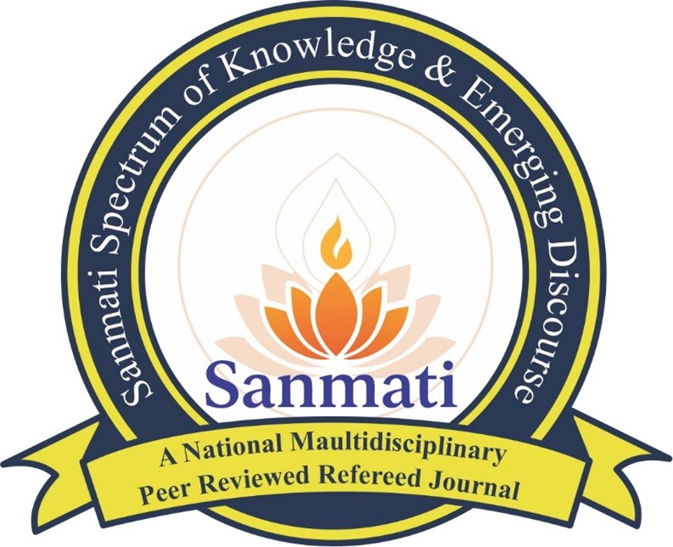
Sanmati Spectrum of Knowledge & Emerging Discourse is a national, multidisciplinary, peer-reviewed and referred quarterly journal. The journal provides a scholarly platform for original research, case studies, thematic articles, book reviews, and conference/seminar papers across diverse disciplines.
Editor-in-Chief

Dr. Namrta Jain
📞 +91 9870713912, +91 8979782949
📧 sanmatijournal@gmail.com
Editor
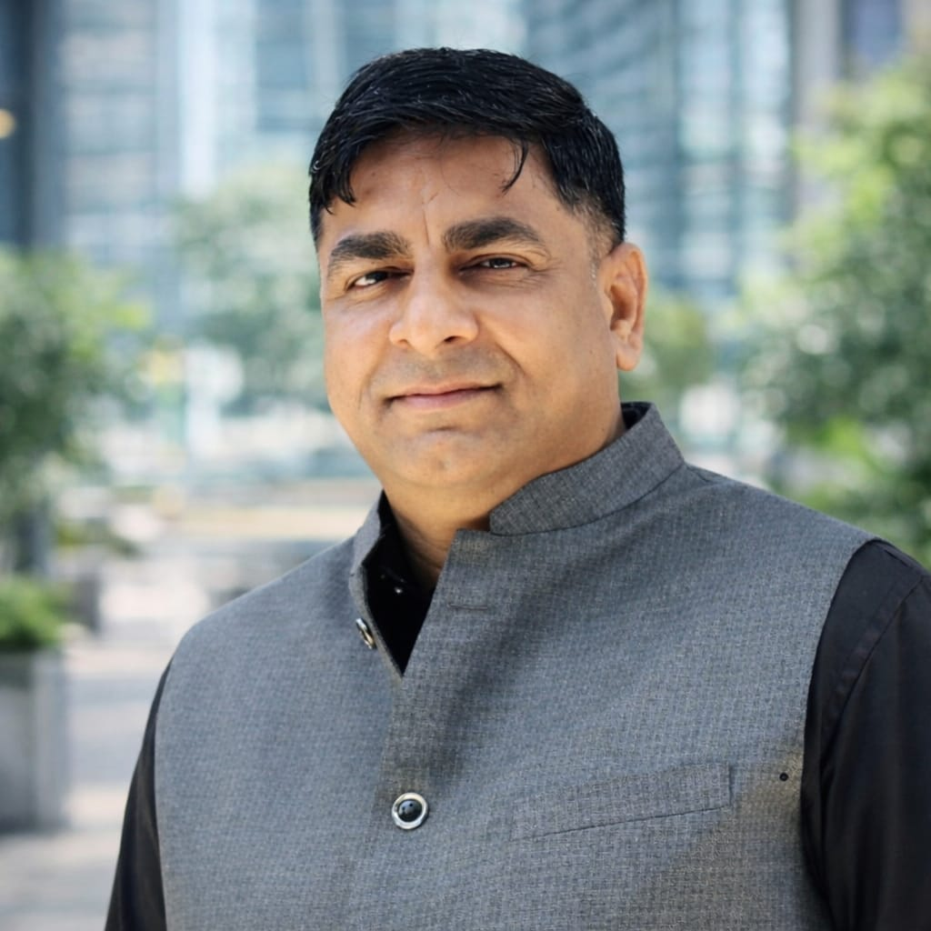
Dr. Ratnesh Kumar Jain
📞 +91 7999525735
📧 jainratnesh79@gmail.com |

2. Basic Information
A-Vision & Mission
Vision
To promote high-quality, ethical, and multidisciplinary research that contributes to knowledge creation and addresses contemporary academic and societal challenges.
Mission
To provide a credible platform for scholars, researchers, and academicians to publish original, peer-reviewed research, encouraging innovation, inclusivity, and academic excellence across disciplines.
B- Objective & Scope
Sanmati Spectrum of Knowledge & Emerging Discourse is a national multidisciplinary quarterly research journal that promotes original research and scholarly discourse in the fields of arts, humanities, social sciences, sciences, and other allied disciplines.
Objective:
The objective of the journal is to provide a national multidisciplinary platform for scholars, researchers, and the academic community. It encourages original research, innovative perspectives, and excellence in scholarly inquiry.
Scope:
The journal publishes research papers, case studies, theme-based articles, book reviews, and research presented at conferences and seminars across arts, humanities, social sciences, mass communication, sciences, and other diverse disciplines. It aims to offer scholars an opportunity to share their ideas and foster multidimensional academic discourse.
C- Journal Information
- Journal Title: Sanmati Spectrum of Knowledge & Emerging Discourse
- ISSN (Print): 3108-1819
- Publication Format: Print (Offline)
- Frequency: Quarterly
- Language: Bilingual (Hindi & English)
- Year of Commencement: 2026
- Nature: National
- Publisher: JTS Publications, V-508 Gali No. 17, Vijay Park, Delhi – 110053

D- About the Journal
Sanmati Spectrum of Knowledge & Emerging Discourse is dedicated to promoting multidisciplinary academic dialogue and advancing knowledge through rigorous research. The journal encourages innovative perspectives that integrate arts, sciences, society, culture, and technology.

3. Editorial Team
A- Editor
Editor-in-Chief
Dr. Namrta Jain
📞 +91 9870713912, +91 8979782949
📧 sanmatijournal@gmail.com
🔗 Google Scholar Profile
Co- Editor-in-Chief
Dr. Ratnesh Kumar Jain
📧 jainratnesh79@gmail.com | 📞 +91 7999525735

B- Editorial Board
- Prof. Pralhad Joshi, Vice-Chancellor, Kumar Bhaskar Varma Sanskrit and Ancient Studies University, Assam
- Dr. Kalpna Jain
Principal / Associate Professor, Teerthanker Mahaveer University, Moradabad
- Prof. S. P. Subashini,
Dean, Faculty of Nursing, Teerthanker Mahaveer University, Moradabad

- Dr. Harishchandra Verma,
Principal/Director, Shri Vishwanath College of Pharmacy, Sultanpur

- Dr. Amita Kumari,
Assistant Professor, Vinoba Bhave University, Hazaribagh, Jharkhand

C- Advisory Board
- Dr. Rakesh Kumar,
Associate Professor, Faculty of Law & Legal Studies, Teerthanker Mahaveer University, Moradabad

- Dr. Sushil Kumar,
HOD (B.Ed.) & Associate Professor, B. N. Mandal University, Bihar

4. Publication & Policy

A- Publication Ethics
Sanmati Spectrum of Knowledge & Emerging Discourse is committed to the highest standards of academic quality, research integrity, and ethical publishing. The journal follows COPE guidelines and expects authors, editors, and reviewers to uphold fairness, transparency, and responsibility. Any form of research misconduct is examined and addressed appropriately.
B- Peer Review Policy
All submitted manuscripts undergo a Double-Blind Peer Review process, in which the identities of both authors and reviewers are kept confidential. This process ensures fairness, objectivity, originality, and academic rigor. Manuscripts are evaluated based on their scholarly merit, relevance, clarity, and contribution to knowledge.

C- Plagiarism Policy
The journal follows a zero-tolerance policy toward plagiarism. All submissions are screened for originality. Manuscripts with a Similarity Index exceeding 20% (excluding references) are rejected without review.

5. Submission Guidelines

A- Call for Papers
Volume 1, Issue 1 | January–March 2026
Sanmati Spectrum of Knowledge & Emerging Discourse invites original, unpublished, and high-quality research papers for its Volume 1, Issue 1 (January–March 2026).

Important Dates
- Last Date of Submission: 25 February 2026
- Notification of Acceptance: Within 10–15 days
- Publication Month: March 2026

B- Areas of Submission
- Arts & Humanities
- Social Sciences
- Journalism & Mass Communication
- Science & Technology
- Education
- Management & Commerce
- Law & Public Administration
- Health & Medical Sciences
- Environment & Sustainable Development
- Indian Knowledge Systems

C- Important Information
- Submission Mode: Email only
- Submission Email: sanmatijournal@gmail.com
- Language: Hindi / English
- Review Process: Double-Blind Peer Review
- Publication Frequency: Quarterly
- Manuscripts: original and unpublished.
- Submission format: MS Word (.doc/.docx)
- Font: Times New Roman (English), Mangal Unicode (Hindi)
- Title: 14 pt Bold | Main text: 12 pt | Line spacing: 1.5
- Abstract: 150–250 words with 4–6 keywords
- Maximum co-authors: Two
- Referencing Style: APA
Researchers, academicians, and scholars are encouraged to contribute and be part of this multidisciplinary academic discourse.
D- Publication Charges
- Per Issue: ₹1200
- Payment via PhonePe / Google Pay in the name of NAMRTA

E- Contact Us
Dr. Namrta Jain
Office – B-002 Faculty Block TMU Campus Teerthanker Mahaveer University Delhi Road Moradabad (U.P) 244001
📞 +91 8979782949, +91 7999525735
📧 sanmatijournal@gmail.com

F- Editorial & Peer Review Process
Sanmati Spectrum of Knowledge & Emerging Discourse follows a transparent, systematic, and rigorous editorial and peer review process to maintain high academic standards.

Submission Process
- Manuscripts are submitted via email to sanmatijournal@gmail.com.
- Initial screening is conducted for scope, format, and plagiarism.

Editorial Screening
- The Editor-in-Chief and Editors assess manuscripts for relevance, originality, and academic quality.
- Manuscripts not meeting basic criteria may be rejected at this stage.

Peer Review Process
- Suitable manuscripts undergo Double-Blind Peer Review, ensuring anonymity of authors and reviewers.
- Reviewers evaluate originality, methodology, clarity, relevance, and contribution to knowledge.
- Review comments and revision suggestions are shared with authors, where applicable.

Editorial Decision
Based on reviewers’ reports, manuscripts may be:
- Accepted
- Accepted with minor revisions
- Accepted with major revisions
- Rejected

Revision & Acceptance
- Revised manuscripts must be submitted within the stipulated timeframe.
- Final acceptance is granted after satisfactory compliance with reviewer comments.

Publication
- Accepted manuscripts are scheduled for publication in the forthcoming issue.
- Authors are informed of publication details via email.
The journal ensures fairness, confidentiality, and academic integrity at every stage of the editorial and peer review process.

6. Compliance

A- Copyright Policy
Authors publishing in Sanmati Spectrum of Knowledge & Emerging Discourse retain the copyright of their work. By submitting their manuscript, authors grant the journal the right of first publication. Proper acknowledgment of all sources is mandatory.

B- Open Access Policy
The journal follows a full Open Access policy, allowing readers to read, download, copy, share, or link to articles, provided the original work is properly cited. All published content is archived digitally and in print for long-term academic preservation and accessibility.

C- Author Declaration
All authors must submit a signed Author Declaration Form along with their manuscript. Authors confirm that:
- The manuscript is original and has not been published or submitted elsewhere.
- All sources are properly cited and acknowledged.
- There is no conflict of interest.
- The manuscript has been checked for plagiarism, and the Similarity Index is below 20%.
Signed declarations must be submitted via email: sanmatijournal@gmail.com
Manuscripts submitted without the Author Declaration Form will not be reviewed.

